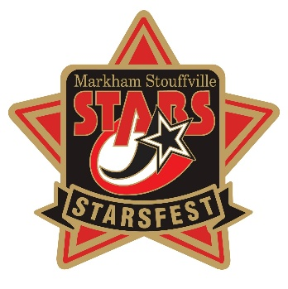
Released Sept 4
Hello Team Officials,
We are excited to announce that we have reached 112 Teams. Thank you for your support!

Tournament Information
- Tournament Headquarters: Clippers Arena – Main Floor
- 2026 Tournament Schedule: Now available in the Documents Section of the main event page.
- Official Website: https://www2.sportacularevent.com/portal//events/event/121
- (Please do not contact arenas or the city for scores). If you find what you believe as an incorrect score, please notify us via email @ info@sportacularevents.com to help expedite inquiries. Please in subject line use: Game Concern - the division and GM# - then share your concern. Saturday is a very busy day for advancing teams. We have a process which identifies which divisions have to be advanced in a chronological process. Many inquiries are made and the pool or divisions has not completed their final RR games in order for us to calculate and advance teams. We appreciate everyone’s patience.
- The 2026 Schedule is now posted in the document section of the main event page
- Teams Do Not have to register at Headquarters
- Team Ramp Game Codes will be made available once everything is uploaded. The OWHA is still populating divisions in the Tournament link, so please remain patient as teams receive their Final Roster Approvals.

Team Roster Submission
- Official PDF Rosters MUST be uploaded to your Sportacular Events account.
- Mandatory request for all teams - Log in to your Sportacular Event Acct, go to MY TEAMS, select your registered team, and click EDIT to update your roster and bench staff to ensure correct contact information is correct. Players only require jersey# and name.
- Yes, it needs to be manually typed in for the information below
- Be sure to save your updates to ensure accuracy for game sheets
- A single-page game sheet system is used for consistency between ice-level officials and administration.
- You may now also, as shown where to Upload your team’s official PDF roster.

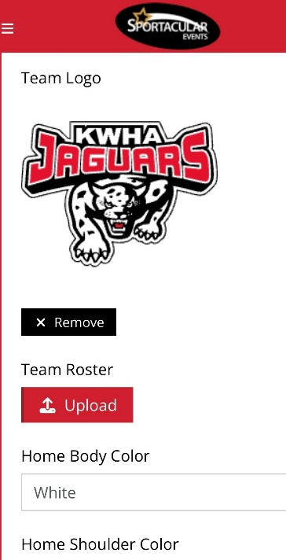
2026 Tournament Updates
- "Player of the Game" awards will be given for every game pickup at Arena Convenor Table in lobby you will sign for the award.
- Special Finals Player of the Game award is a commemorate gold medal
- Championship Finals: Winners receive Gold Medals and an Arena Banner; finalists receive Silver Medals.
- New Awards: Same as Player of game awards, if a player has a Hat Trick or Shutout
  - "Wholly Moly Who's That Goalie" Shutout Awards
  - "Holy Hat Trick" Awards for players scoring a hat trick

Important Rules & Reminders
- Player Eligibility: Players can only compete with one team in one tournament during the weekend
- Pickup Players: Any team using an OWHA Pickup Players must follow these rules or face Forfeiture and or Suspensions and fines.
- Any team Found to be using an illegal player or playing suspended players will be removed from the tournament and any further games will result in Game Forfeitures. The OWHA Will also be notified as required
- Rep Teams: Allowed max 3 replacements but cannot replace suspended players. Rep teams may only use Players from below levels of play – No Lateral Callups even if playing up in a combined division. If a team has been found to use an illegal callup or player the team will be removed from the event
ALL Teams cannot exceed their official roster limit at any time.

- Equipment Rules:
- USA Teams: Mandatory mouthguards (per USA Hockey Insurance).
- Canadian Teams: Mandatory BNQ neck guards (per Hockey Canada)
- Suspensions: Hockey Canada and OWHA SUSPENSION rules shall apply where required. All suspensions must be reported to OWHA via email and await their direction as to number of games. You must comply. Clearance must be received before returning to play. Teams from out of Province will be notified of IF a member of team is under suspension
- Travel Permits: All out-of-province teams must submit their travel permits and email to Sportacular Events. If Travel permit is not provided the team is not allowed to play it’s a Hockey Canada Insurance Rule
- Rosters: Have a copy of your roster available in the event of any discrepancy
- Tournament Rules: Posted live on the Sportacular site. Please also note we do not use GF/GA we instead use the Tie Breaker Calculator chart in the document sections.
- Home Teams will wear Dark colored Jerseys and visitor teams will wear light.

Game Day Procedures
- Jersey Color Conflicts: Teams should bring an extra set of jerseys or pinnies to avoid conflicts.
- Championship Awards & Photos: Arena banners and medals will be awarded off the ice due to safety and City and Town insurance regulations
- Dressing Rooms:
  - Bring your own lock where required.
  - Keep rooms clean before vacating.
- Game Start Times: Games may begin up to 20 minutes early based on arena convenor coordination
- Check-in Requirements: Team managers or head coaches should check in with arena convenor in lobby before each game. You do not need to check in a headquarters.
- Player of the Game Award: A player of the game DOG TAG will be provided at the sign in table prior to the start of each game and awarded by the coach who will sign for the item
- Shutout/Hatrick Awards: Available at the convenor table at the end of your game
- Identifying Event Staff: Sportacular Event Staff will wear red jackets with “Event Staff on the bank. Ask for help at any game sheet sign-in area
- RAMP Game Codes: Will be emailed and also available at game sheet convenor tables.

Final Notes
- 2026 Tournament Rules Sunday Posted Live and in Document section
- If we promised thank-you or incentives items, please remind us before the first game so we have them ready for you.
- Stouffville arena has additional parking behind the rinks

FYI: Saturday at Clippers Complex there is also a firehall open house 10-2 I we believe overflow parking will be at Stouffville District secondary school just south of the arena.

We look forward to seeing you all in soon to officially Kickoff the new season!
Check the event main page for ongoing updates. https://www2.sportacularevent.com/portal//events/event/121
Thank you, and best of luck to all teams!
Tournament Vendors
Stouffville Arena
- Clothing Vendor
- Authentic Memories Team and Action Photos
- Busy Beads Croc Charms
- Lily The New Products Toy Lady The hottest items for this year
Clippers Arena
- Clothing Vendor
- Tammy Mr. C Freeze Dried Treats
- Lily The New Products Toy Lady The hottest items for this year
Thornhill CC
- Busy Beads Croc Charms
- PWHL Pop Up Shop FRIDAY Only

Canlan Scarborough
Designated Warm up Areas:
Please note that loud music is not permitted in any of the Lobbies in Markham, Stouffville and Richmond Hill Rinks. In addition, that the playing of Loud Music is Prohibited behind the townhouses to the West of the Stouffville Arena.
Designated Warm up Areas:
Stouffville Arena
Indoors at the back of the rinks on Pad A & B or on Outdoors on the soccer Fields or Track.
Stouffville Clippers Complex
In the upper Area of the rinks or inside the Rinks or outdoors on Grassy Areas.
Angus Glen CC
Designated indoor warm up areas are inside the rinks. Warms ups and loud music are not permitted anywhere else inside the complex. There are soccer fields in the back of the complex or out front on grassy areas.
Thornhill CC
See convenor on site for specific locations
LIVE BARN
Live Barn Markham at Angus, should be live.
Town of Stouffville has confirmed all rinks at Clippers & Stouffville Arena will be available on Live Barn as well.

Skate Sharpening Info:
Stouffville:
There is skate sharpening available at Stouffville Arena and Clippers Complex by Cutting Edge Pro Shops https://cuttingedgeproshops.com/locations/stouffville/skate-sharpening-stouffville/. He will have guys at both rinks all weekend if anyone asks. I spoke to him on Tuesday evening and told him how late the games go each day and that they start at 8AM and onward. Pro Wear Sports https://prowearsports.com/ in plaza with the Esso also has skate sharpening
In Markham sometimes at Angus Opening TBC
Thornhill CC: Details TBC
https://www.hockeylion.ca
Skate Sharpening HOCKEY LION RICHMOND HILL
9821 Leslie Street, Unit 106
Richmond Hill, L4B 3Y4
Ontario, Canada
Opens 10 AM on Fri/Sat/Sun
HOCKEY LION MARKHAM
6050 Highway 7 East, Unit 4
Markham, L3P 3A9
Ontario, Canada
Opens 10 AM on Fri/Sat closed Sunday

